Standish House Public Consultation Event

Friday 27th January, 2-6pm & Saturday 28th January, 9am-12noon

At Standish Village Hall
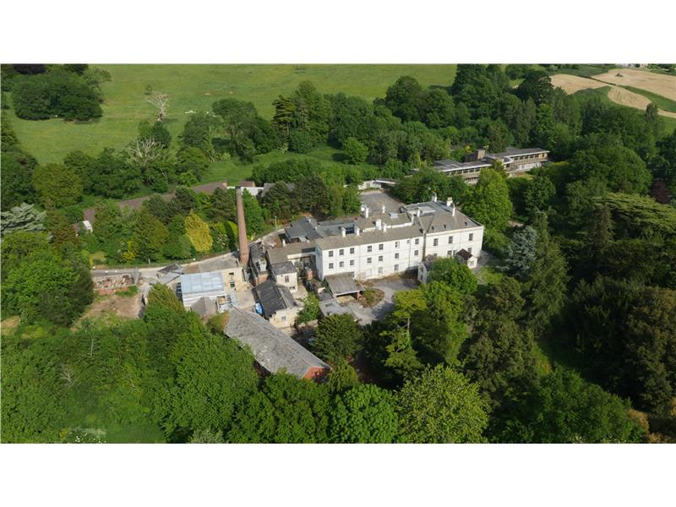
PJ Livesey, the developers for Standish House, have organised this event to share details of their current plans for the site. There will be displays and their design/consultant team will be on hand to answer questions and hear your views.

Standish Parish Council hopes that as many local people as possible will come along and take part in this important event. Feel free to come and go as you please.

Display boards will be made available online after the event for those who are unable to make it on the weekend.

