GUIDE TO PARKING AT STANDISH VILLAGE HALL
Information for all visitors to Standish Village Hall:
The Village Hall has a small car park which can accommodate 14 cars – if parked properly!
1) First arrivals: please park facing the white metal railing on the left (8 cars). Then a further 6 cars can park perpendicular to (facing) the grassed area to the right (end on – not parallel).
N.B. the grassed area adjoining the car park (a.k.a. “The Pound”) is private property.
2) Overflow parking: When the car park is full – please park off-road on the grass under the trees opposite the Village Hall (8 cars) and then off-road along Standish Lane (15+ cars). We can fit in many more cars if you drive onto the grass verge and park end-on facing the hedge and not on the road!
N.B. PLEASE DO NOT PARK ON THE ACCESS ROAD TO THE HALL LEADING TO THE STONE ARCHWAY. THIS IS PRIVATE PROPERTY AND ACCESS FOR EMERGENCY SERVICES MAY BE REQUIRED AT ANY TIME.
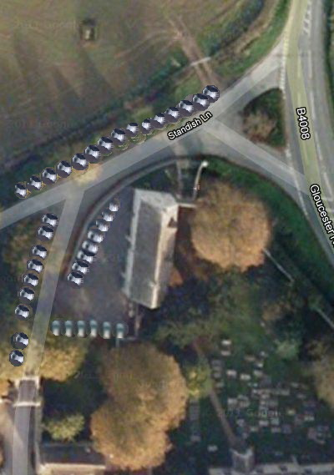
For Standish Village Hall Management Committee
Standish Village Hall, Church House, Standish Lane, Standish, Stonehouse, Glos GL10 3DW

